An invitation from

Mr. John Leech MP.
Chairman,
All Party Parliamentary Light Rail Group

To a

Parliamentary Tea.

Tuesday 12th July 2011

1600h – 1800h.

In the
Terrace Marquee
House of Commons

The launch of the
“Light Rail Review”

Speakers,

Mr Norman Baker MP,
Parliamentary Under Secretary of State for Transport

Mr. Robert Whyte,
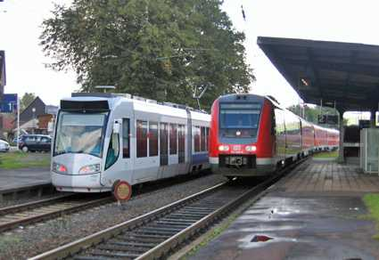  Mainline TrainTram | 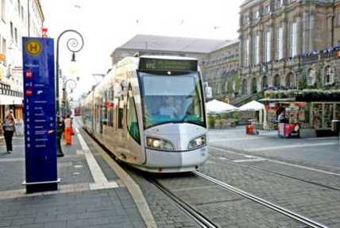  Main Street  TramTrain | 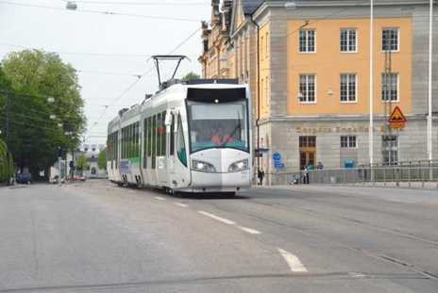  Suburbs  TrainTram & TramTrain
Alstom Transport UK Ltd,

“Trams do it GREEN and Cheaper
on lightly used railway lines and connect to the town streets”

Alstom have generously sponsored this event.

Reply Form

Name……………………….(MP)

□ Yes, I intend to attend.

□ I cannot attend but I wish_______ to attend in my place

□ I cannot attend

□ I would like………… to be raised at one of the meetings

Please fax back to 01925 243500
Or e-mail
applrguk@aol.com

Many thanks for your help

